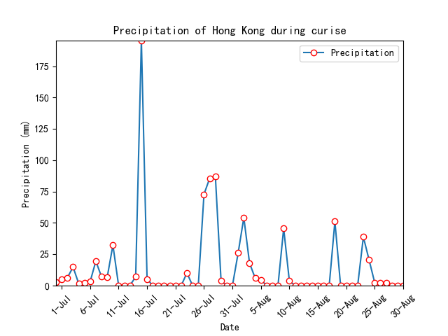

Supporting Information Figure 7: Precipitation during July 1st 2006 to August 31st 2006